Measuring Political Bias Transfer from LLM-Generated Training Data to Stance Classifiers
Course: DSCI 690 — Spring 2026
Milan Varghese
Aim: LLMs like GPT-4o and Llama-3 are increasingly used to generate synthetic training data for NLP tasks. But these models carry their own political biases. This project tests whether those biases silently transfer to classifiers trained on LLM-generated data, using political stance detection on tweets as the test case.
Research Questions
- Does training on GPT-4o synthetic tweets shift classifier predictions on real tweets compared to training on real data?
- Does Llama-3 synthetic data produce a different shift than GPT-4o, matching each model's known political lean?
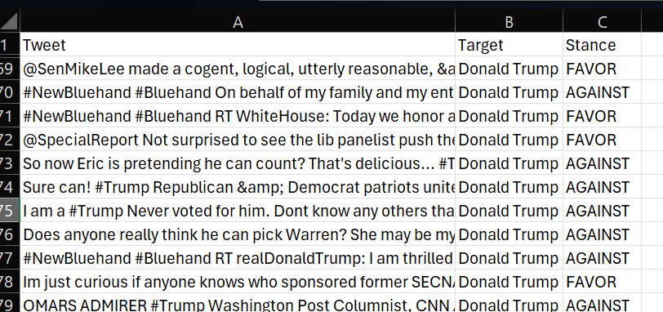
- Does mixing real and synthetic data reduce the shift?
Project Plan
Dataset: P-Stance (21,574 real tweets labeled Favor/Against toward Trump, Biden, Sanders). Binary classification task. https://github.com/chuchun8/PStance

Synthetic data: Generate ~7,200 tweets each using GPT-4o (Heavily aligned model via RLHF) and Llama-3-8B (less intensive alignment) with neutral prompts, balanced across 6 target × stance combinations.
Models trained: RoBERTa-base (full fine-tuning) and Llama-3-8B (LoRA), each under 4 conditions: real tweets only, GPT-4o generated only, Llama-3 generated only, mixed.
Evaluation: All 8 classifiers are tested on the same held-out real P-Stance test set rather than on synthetic data. Any difference in predictions reflects only the training data. We measure two layers: (1) standard performance (Macro F1, Precision, recall per target), and (2) per-target prediction shifts vs. the real-data baseline.
Timeline:
Week 1: Data + generation setup
Week 2: Generate synthetic data, train RoBERTa
Week 3: LoRA fine-tune Llama-3, run evaluations
Week 4: Analysis and midway presentation
Week 5: Final paper and presentation

References
Feng et al. (2023). Tracking Political Biases in NLP Models. ACL Best Paper.
Li et al. (2021). P-Stance: A Large Dataset for Stance Detection. Findings of ACL.
Röttger et al. (2024). Political Compass or Spinning Arrow? ACL.
Santurkar et al. (2023). Whose Opinions Do Language Models Reflect? ICML.
Wagner et al. (2025). LLM-Generated Synthetic Data for Stance Detection. ICLR Spotlight.

